DATE: July 09, 2021
FOR IMMEDIATE RELEASE

Getty Exhibition Reassembles Medieval Italian Triptych

Paolo Veneziano: Art and Devotion in 14th-Century Venice

is the first monographic exhibition on the artist in U.S.
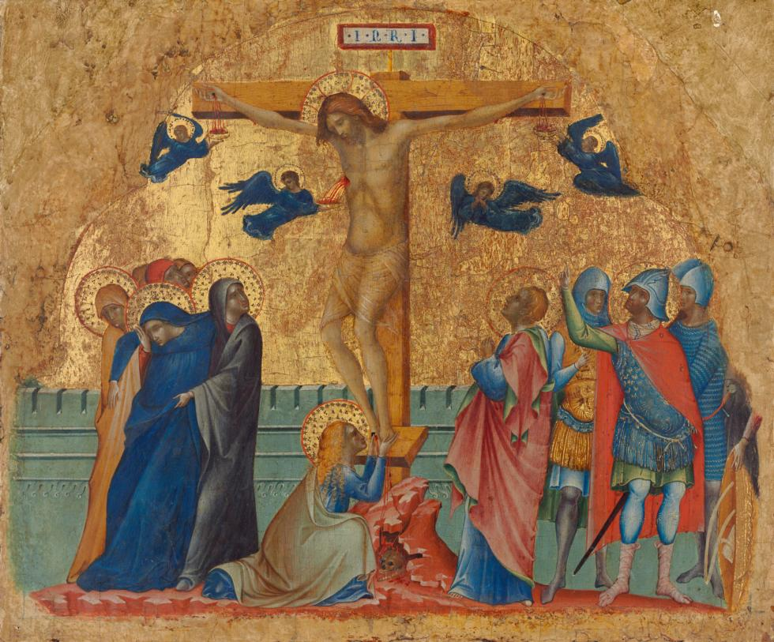
The Crucifixion, about 1340-1345 Paolo Veneziano (Italian (Venetian), about 1295 - about 1362) Tempera and gold leaf on panel Unframed: 33.9 × 41.1 cm (13 5/16 × 16 3/16 in.) Framed: 37.2 × 45.4 × 5.7 cm (14 5/8 × 17 7/8 × 2 1/4 in.) National Gallery of Art, Washington, Samuel H. Kress Collection, 1939.1.143

LOS ANGELES - Paolo Veneziano (about 1295–about 1362) was the premier painter in late medieval Venice, producing religious works ranging from large complex altarpieces to small paintings used by Christians for personal devotion. A new exhibition, on view at the J. Paul Getty Museum, Getty Center, from July 13 through October 3, 2021, brings together numerous paintings that reveal the delicate beauty and exquisite colors that distinguish Paolo Veneziano’s art. The centerpiece of the show reunites painted panels that originally belonged together but are today housed in different collections.

“It is fairly commonplace for museums around the world to own fragments of what were once larger ensembles, dismantled in later centuries for sale on the art market,” explains Timothy Potts, Maria Hummer-Tuttle and Robert Tuttle Director of the J. Paul Getty Museum. “Paolo Veneziano: Art and Devotion in 14th-Century Venice presents a rare exception: a completely intact triptych for personal devotion, on loan from the National Gallery of Parma, Italy. The appearance of this triptych was the basis for the reconstruction of an almost identical triptych, the so-called Worcester triptych, reassembled for the first time in this exhibition.”
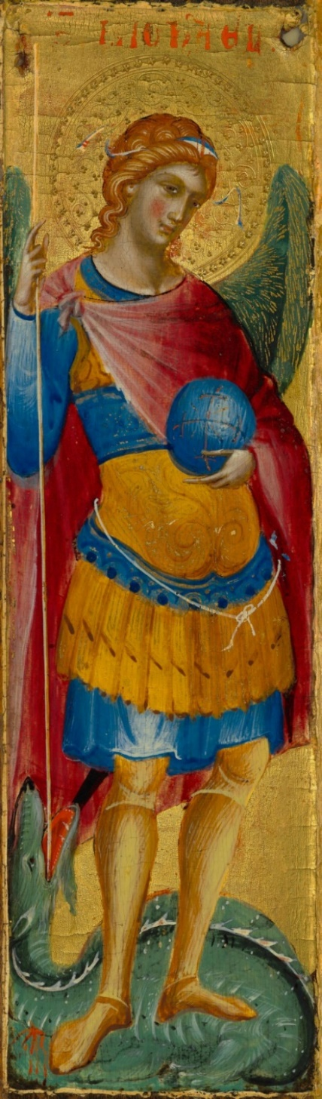
Portable devotional triptychs, self-supporting and with closable shutters, were regularly made by artists and craftspeople in Venice throughout the fourteenth century. It is a type that seems to have been invented in Paolo Veneziano’s workshop.

The reconstruction presented in the exhibition offers a rare glimpse into how the artist’s devotional works were first experienced. Through scientific investigations and visual analysis, Getty conservation scientists and curators determined that a series of panels – today divided between the Getty Museum (Annunciation), the National Gallery of Art, Washington (Crucifixion), and the Worcester Museum of Art (Seven Saints) – were originally part of the same ensemble, a triptych remarkably similar to the one that remains intact in Parma. In both, narrative scenes from the life of Jesus Christ are combined with iconic depictions of saints. The reconstructed altarpiece is lacking its central panel, which likely depicted the Virgin Mary and Christ Child, as seen in the intact altarpiece in Parma. This missing panel remains to be discovered. The surviving panels have been reassembled for the first time using a specially constructed metal armature. This reconstruction, together with other paintings by Paolo and his workshop, offers a rare opportunity for viewers to explore the unique visual culture of 14th-century Venice.

“With elaborately gilded surfaces, punched and manipulated to create precious visual effects, and expressively conceived combinations of brilliant colors, Paolo Veneziano’s paintings are a feast for the eye,” said Davide Gasparotto, senior curator of paintings at the Getty Museum. “Paolo’s oeuvre is often characterized as straddling the painterly traditions of the eastern and western territories, where Byzantine cadences find harmony with the recent developments of painting on the Italian peninsula. This exhibition contextualizes Paolo’s work in relation to the transformative and cosmopolitan cultural landscape in Venice during the artist’s lifetime.”

In Paolo’s paintings, intricately worked gold grounds and hieratic representations of saints are brought together with naturalistic narrative scenes and complex renderings of spatial form to spectacular effect. Moving beyond a traditional tendency to examine the artist’s intermingling of cultural styles in terms of his own body of work, this exhibition instead explores how his work was born out of, and in turn contributed to, the broader artistic milieu of 14th-century Venice.
Archangel Michael, mid-14th century
Paolo Veneziano (Italian (Venetian), about 1295 - about 1362)
Tempera on panel Worcester Art Museum, Worcester, MA, Museum Purchase, 1927.19
EX.2021.3.13.c

During Paolo’s lifetime, Venice was a powerful, multicultural city and Venice’s art and architecture reflected this unique cosmopolitanism. The exhibition showcases several painted works of art produced in Paolo’s workshop and explores his participation in the sophisticated visual culture continually developing around him. A selection of contemporaneous works in other media—carved ivory, illuminated manuscript, and woven silk—demonstrate the cross-pollination between different kinds of art-making that underpinned Venetian artistic production.

The exhibition was conceived by Laura Llewellyn (former Assistant Curator at the Getty Museum, now Associate Curator of Renaissance Paintings at the National Gallery, London) and John Witty (former Anne L. Poulet Fellow at The Frick Collection, New York), supported by Davide Gasparotto (Senior Curator of Paintings, Getty Museum) and Xavier Salomon (Deputy Director and Peter Jay Sharp Chief Curator at The Frick). The exhibition is accompanied by a publication from The Frick Collection, which presents Paolo Veneziano’s oeuvre alongside contemporaneous objects in various media to demonstrate how his innovative work engaged with 14th-century advances in manuscript illumination, ivory carving, textile production, and metalwork.

The exhibition was conceived in collaboration with The Frick Collection, New York, and is supported by the Getty Museum’s Paintings Council. It will be shown exclusively at the Getty Museum.

MEDIA CONTACT:
Amy Hood
ahood@getty.edu
(310) 440 -6427
Getty Communications

###

Getty is a leading global arts organization committed to the exhibition, conservation, and understanding of the world’s artistic and cultural heritage. Working collaboratively with partners around the globe, the Getty Foundation, Getty Conservation Institute, Getty Museum and Getty Research Institute are all dedicated to the greater understanding of the relationships between the world’s many cultures. The Los Angeles-based J. Paul Getty Trust and Getty programs share art, knowledge, and resources online at Getty.edu and welcome the public for free at the Getty Center and the Getty Villa.
The J. Paul Getty Museum collects Greek and Roman antiquities, European paintings, drawings, manuscripts, sculpture and decorative arts to 1900, as well as photographs from around the world to the present day. The Museum’s mission is to display and interpret its collections, and present important loan exhibitions and publications for the enjoyment and education of visitors locally and internationally. This is supported by an active program of research, conservation, and public programs that seek to deepen our knowledge of and connection to works of art.
Visiting the Getty Center
The Getty Center is open to a limited number of visitors, in accord with state and local public health guidelines, Tuesday through Sunday, 10 a.m. to 5 p.m. It is closed Mondays, Thanksgiving, December 25 (Christmas Day), and January 1.

Admission to the Getty Center is always free, but in order to allow social distancing, a reservation is currently required for admission. Reservation are available at www.getty.edu/visit or at (310) 440-7300. Parking is $20. The Getty Center is at 1200 Getty Center Drive, Los Angeles, California.

Additional information is available at www.getty.edu. Sign up for e-Getty at www.getty.edu/subscribe to receive free monthly highlights of events at the Getty Center and the Getty Villa via e-mail, or visit www.getty.edu for a complete calendar of public programs.

