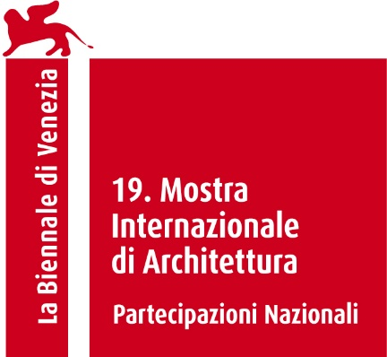

JAPAN PAVILION
At the 19th International Architecture Exhibition - La Biennale di Venezia

IN-BETWEEN
Curated by Jun Aoki

Press Release

The Japan Foundation announces the Japan Pavilion exhibition at the 19th International Architecture Exhibition - La Biennale di Venezia, which will be held in Venice from 10 May to 23 November 2025. IN-BETWEEN, this is the title of the exhibition, which will be curated by architect Jun Aoki, fully follows the theme proposed by the curator of this edition of the Biennale Architettura 2025, Carlo Ratti: “Intelligens. Natural. Artificial. Collective”.

At the root of the climate crisis lies the way we humans relate to our surrounding environment. It stems from a human-centered arrogance that regards humans as the subject and the environment as an object to be manipulated and used.
Jun Aoki, the curator of the Japan Pavilion proposes a reflection that unless we fundamentally change this attitude, there can be no true solution to the climate crisis. What the Japan Pavilion presents is a new—and at the same time, ancient—attitude and vision to replace this long-standing perspective.
In short, it is the idea that humans must stand on a horizon where we and the environment are equal, a realm beyond the subject-object dichotomy. In the old Japanese language, this is expressed as ma, or the “In-Between.”

Hence the invitation to rethink our perception of the subject-object dichotomy and to update our intelligence. What is proposed is the idea of ma, or “in-between time-space.” Originally, ma referred not only to the in-between time-space in everyday sense but more to the tension that arises from the dialogue between two things, and the idea that this tension acts as a metaphysical object. Based on this idea, the subject is neither in us humans nor the world ouside of us; rather, subjecthood exists in a world of a completely different realm, the in-between. In the in-between, there is no distinction among humans, non-humans, nature, and man-made objects. The in-between is the very state of dialogue among those elements, and the new nature of intelligence lies in this space.

This project takes the Japan Pavilion as the experimental grounds for pursuing this new kind of intelligence. The elements that make up the pavilion––the Hole, Wall Columns, Outer Walls, Brick Terrace, Pensilina, Tilted Loop Path, and Yew Tree–– with the human team of curators and two artist-architect pairs, engage in a dialogue, both fictionally and actually. Together, we imagine a future of the Japan Pavilion–– a near future, where things are just a little different.

IN-BETWEEN
10 May to 23 November 2025

CREDITS
Commissioner: The Japan Foundation
Curator: Jun Aoki (architect and director of AS Co., Ltd.)
Exhibitors: Tamayo Iemura, Asako Fujikura + Takahiro Ohmura, SUNAKI (Toshikatsu Kiuchi and Taichi Sunayama)
Venue: Giardini della Biennale di Venezia

Jun Aoki
Born in Yokohama, Japan, in 1956. He graduated from the University of Tokyo in 1982. After working with Arata Isozaki and Associates, he founded Jun Aoki & Associates (reorganised into AS in 2020). Subsequent works include: Mamihara Bridge; Fukushima Lagoon Museum; Aomori Museum of Art (Architectural Institute of Japan annual award); Louis Vuitton Nagoya Sakae; Omiyamae Sports Centre; Miyoshi City Holl KIRIRI and Kyoto Municipal Museum of Art (KYOCERA Museum of Kyoto City), (collaboration with Nishizawa Tezzo, Architectural Institute of Japan annual award). Director of the Kyoto Municipal Museum of Art (Kyoto City KYOCERA Museum). Emeritus Professor, Tokyo University of the Arts.

The Japan Foundation
The Japan Foundation (JF) is Japan's only institution dedicated to carrying out comprehensive international cultural exchange programs throughout the world. The Japan Foundation was established in October 1972 as a special legal entity supervised by the Ministry of Foreign Affairs. In October 2003, it was reorganized as an incorporated administrative agency. The Japan Foundation has 26 overseas offices in 25 countries. To cultivate friendship and ties between Japan and the world, the Japan Foundation creates global opportunities to foster friendship, trust, and mutual understanding through culture, language, and dialogue. Since 1976, the Japan Foundation has been organizing the Japan Pavilion at both art and architecture exhibition of La Biennale di Venezia. On the occasion of 70th anniversary of Japan’s official participation in the International Art Exhibition of La Biennale di Venezia, Japan at the Venice Biennale 1952-2022 is published by Electa.

Press Office
ESSECI Studio
Press kit and photos: www.studioesseci.net
Ref. Roberta Barbaro - E-mail: roberta@studioesseci.net
+ 39 (0)49663499; M. + 39 331 614 73 73

